Todo List Management System

22000481 Yohan Yoon

Description:

I implemented a Java program that can manage my schedule for the whole week. To achieve this, I made 8 to-do lists for deadline, Monday, Tuesday, Wednesday, Thursday, Friday, Saturday, Sunday so that I could add a schedule for a specific day.

The first time you initialize the program, it asks you for the first day of the semester and it automatically calculates the number of weeks you are in and displays it on the screen. Then you can add a todo or a deadline or a weekly schedule which has different features each. Deadline and weekly are children of todo, and they all share the same interface. You can also edit or delete the list items and save them to a text file so that whenever you run the program, your previous actions would be there. There is also a search feature that helps you search for the deadline for a specific schedule.

Utilizing this program, you can efficiently manage your schedule and keep track of things you did and have to do.

Github link: <https://github.com/yoyohanyy/FinalProject.git>

UML diagram:

User’s guide:

Initialization

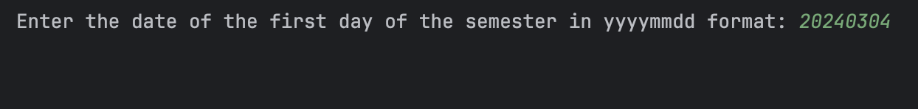

Add

Edit

Delete

Search

Save

Result

todolist.txt

